source: [Bayes' rule: Guide](https://arbital.com/p/bayes_rule/?l=1zq)

## Frequency Diagrams

ex:

20% have the disease

90% of sick test positive

30% of healthy test positive

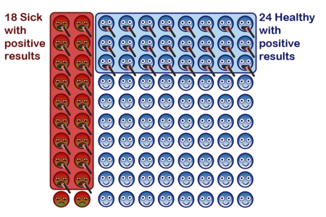

18 + 24 = 42 students tested positive

18/42 = 43% success rate

## Waterfall Diagrams and Relative Odds

Bayes’ rule: prior odds * likelihood ratio = posterior odds

ex:

20 gal/sec of red water

80 gal/sec of blue water

90% of red water goes to the shared pool

30% of blue water goes to the shared pool

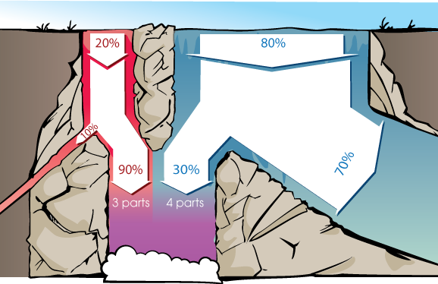

prior odds (20% : 80%) = (1 : 4)

likelihood ratio (90% : 30%) = (3 : 1)

posterior odds (1 : 4) * (3 : 1) = (3 : 4)

strength of evidence: ratio of true positive and false positive or false negative and true negative

conditional probability P(X|Y): the probability of X, assuming Y is true

P(X|Y) = P(X∧Y)/P(Y)

P(A|B) = P(B|A) * P(A) / P(B)